HemoSim edit doc - I14
HOW TO USE: edit the wording directly (Track Changes if you like). For layout or a figure (size, position, wrong/missing image) write a short instruction in [brackets] right where it applies. Send it back and I apply the wording to the page and the layout notes to the styling, then regenerate. This is a content+notes doc, so it will not look exactly like the web page.

ISSUES FLAGGED FOR THIS MODULE (5)
These were found while the module was built and are not part of the prose. SOURCE means the defect is in a deck, a Notion page or the source index and has to be fixed there too. DECISION means it needs your call before the page is final. NOTE is for information. Answer them in [brackets] like any other instruction.
[SOURCE: The v2022 deck teaches tamponade incorrectly in two places. Slide 308: "one can detect this by noting a loss of x and y descent." Slide 309: "Tamponade causes loss of x and y descents." The x descent is preserved and usually dominant, because ejection is the only moment total cardiac volume can fall. Only the y is lost. Confirmed against Zhang, Kerins and Byrd, Echocardiography 1994, PMID 10150627. Slide 308 also contradicts itself, since its own question asks why tamponade lacks a prominent y descent and its annotated figure marks loss of the y alone. The correct version is already in the library at pac-modules-patrick-lindsay-v1 slide 121, so the fix is a copy. These slides feed the N7 topic 3 bank and the sim-day items, so the error propagates.]
[DECISION: Three of our own sources disagree on where to read a right atrial pressure, and this needs a curriculum-level answer rather than a per-module one. v2022 slide 293 says the z point. This page and Magder say the base of the c wave, the same instant. pulmonary-artery-catheter-1 slide 11 says average the top and bottom of the a wave. I15 says the peak of the a wave, after v2022 slide 277. n7-t3 says the a wave averaged top to bottom. They diverge in exactly the patients where the reading changes management. Every location is marked in the HTML with TODO-CVPREAD. Once decided, all four pages get corrected together.]
[NOTE: The Notion "CVP Waveform Alterations" page is empty, title line only, so this module was built from the v2022 RA module instead. Decided 2026-08-17 that the Notion page will not be backfilled. This page is the curriculum's treatment of the material.]
[NOTE: Two claims were dropped for want of support: the deck's claim that a femoral CVP tracks RA pressure within about 1 mmHg, kept as the curriculum's own practical guidance rather than attributed to literature, and any percentage for the atrial contribution to RV filling, where only LV data exists.]
[NOTE: The five abnormal CVP tracings are stored as TIFF, which browsers do not render. They were converted to PNG keeping source-derived filenames.]

Right atrial and CVP waveform interpretation
Three modules have already taken the right atrial pressure apart as a number. Module I8 established what it is physiologically, not an input the clinician sets but the pressure at which the venous return relationship and the cardiac function relationship intersect. Module I11 established what it cannot do, which is report preload. Module I3 established the conditions under which it means anything at all: a faithful fluid column, a transducer levelled at the phlebostatic axis, and the understanding that the monitor reports a pressure referenced to the room while the heart responds to the pressure across its wall.
What none of them touched is the shape. Between one atrial contraction and the next the pressure in the right atrium rises three times and falls twice, and every one of those five deflections is generated by a specific mechanical event with a specific cause. A mean value discards all of it. The waveform also escapes the objection that sinks the mean, because it does not ask you to convert a pressure into a volume. It reports directly on the rhythm, on the competence of the tricuspid valve, on the diastolic properties of the right ventricle, and on whether anything outside the heart is constraining it. Those are four separate diagnoses and the digital number contains none of them.
The module takes the trace in the order the bedside requires. First the normal waveform, deflection by deflection, each tied to the mechanical event that produces it and to the electrocardiographic landmark that dates it. Then the measurement, because a waveform read at the wrong point in the respiratory cycle, or from a system that has smoothed the detail away, is worse than no waveform at all. Then the pathological series, each abnormality traced back to its mechanism, so that a pattern you have never seen before is still readable.

What the right atrial trace is a recording of
Right atrial pressure and central venous pressure are used interchangeably throughout, as they are in practice, on the understanding that a catheter tip in the proximal superior vena cava sees essentially what a tip in the atrium sees. What the transducer records is the pressure generated by venous blood inside a thin-walled, highly distensible chamber that is in open continuity with the great veins for most of the cardiac cycle and sealed off from the ventricle for the rest of it.
Four properties determine the shape of the resulting trace, and every abnormality later in the module is a disturbance of one of them. Right ventricular function, systolic and diastolic. Pleural pressure, transmitted across the compliant atrial wall, which moves the whole trace up and down with every breath. The tricuspid valve, whose opening and closing define which parts of the cycle the atrium spends connected to the ventricle. And the cardiac rhythm, which sets whether the atrium contracts at all and whether it contracts at a useful moment.
One quantitative fact governs the interpretation of every deflection, and it does more work than any list of patterns.
ΔP = ΔV ÷ CΔP, the height of a pressure deflection; ΔV, the volume shifted into or out of the chamber during that phase of the cycle; C, the compliance of the chamber receiving the volume. The relationship is the definition of compliance rearranged, and it holds for every wave on the tracing.
For pressure changes produced by volume entering or leaving a compliant chamber, the size of the deflection depends principally on how much volume moves and the compliance of the chamber receiving it. A given volume shift generates a larger pressure change when the receiving chamber is less compliant. When flow must also cross an obstructed valve, however, the pressure gradient required to move that volume becomes an additional determinant. Reading a trace is therefore never a matter of recognising shapes from an atlas. It is a matter of asking what volume moved, what chamber received it, how compliant that chamber was, and whether anything obstructed the path between them.
The second thing to internalise is the scale. A normal mean right atrial pressure is 0 to 6 mmHg and the individual waves within it are a few millimetres of mercury tall, against fifty or sixty for a systemic arterial excursion. Both classes of error Module I3 catalogued therefore land harder here. A transducer set 10 cm below the phlebostatic axis adds about 7.4 mmHg to every reading, which nobody notices on an arterial line and which more than doubles a central venous pressure of 6. And an overdamped fluid column, which merely rounds off an arterial trace, can erase the c wave outright, blunt both descents, and turn the distinctive tracing of tricuspid regurgitation into something unremarkable. Everything below assumes a system that has passed a fast flush test. If it has not, the shape you are interpreting may belong to the tubing.

The normal waveform, wave by wave
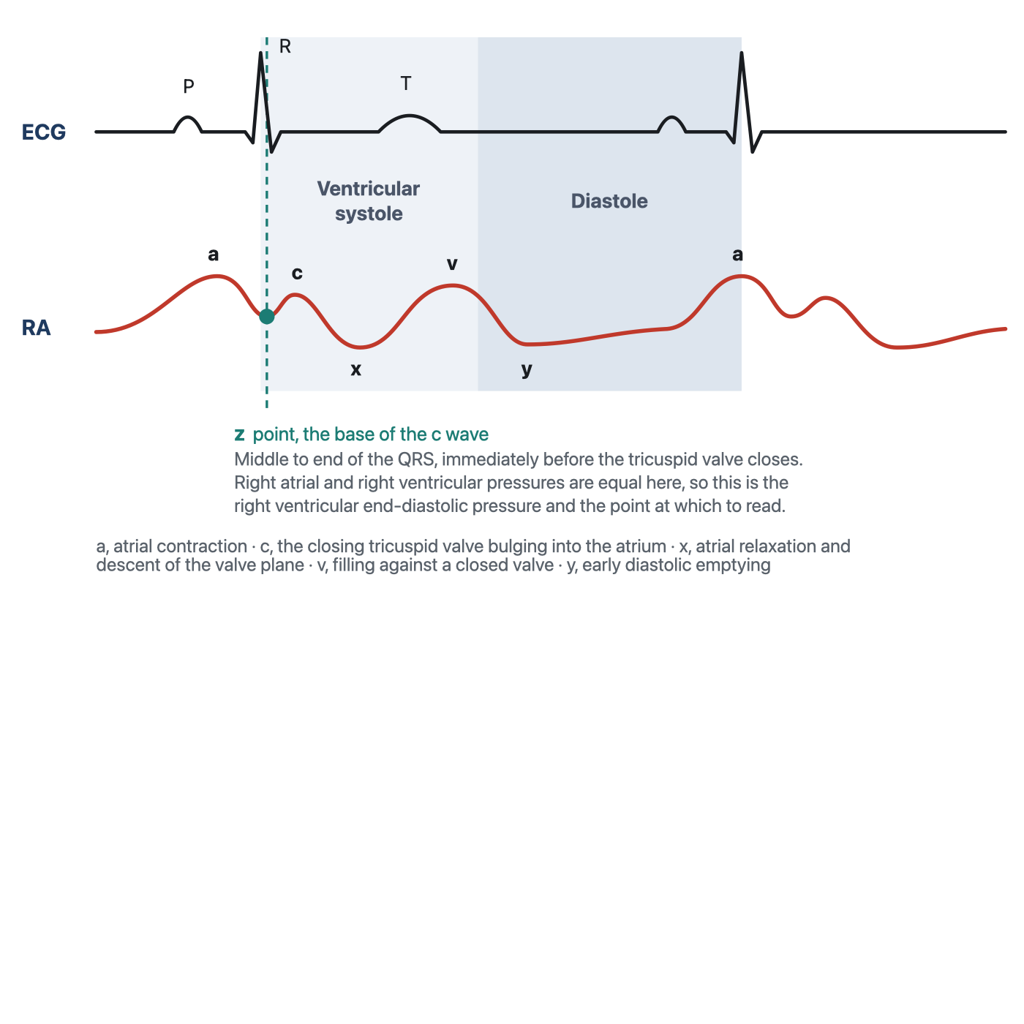
The five deflections of the normal right atrial trace, each tied to its mechanical event and to the electrocardiographic landmark that dates it. The z point is added here because it is the point at which the pressure should be read, and it is the subject of the next section.
[Layout note: figure shown small here. On the web it is currently capped at 640px wide. Say if you want it smaller/larger, moved, cropped, or replaced.]
The a wave is the first positive deflection of the cycle and it is produced by atrial systole. It follows the P wave rather than coinciding with it, because the P wave is the electrical event and the pressure rise is its mechanical consequence, separated by the time required for depolarisation to propagate and for the myocardium to develop tension. That is why the a wave sits inside the PR interval, and it is the same electromechanical delay Module I3 quantified on the arterial side.
Its amplitude follows the equation above. The volume moved is whatever the atrium can eject in the last fraction of diastole, and the compliance that matters is that of the right ventricle at end diastole, since that is the chamber receiving it. The normal right ventricle is the most compliant chamber in the heart, so a normal a wave is small. It is also normally the tallest of the three positive waves, slightly exceeding the v wave, which gives a useful internal reference: when the v wave clearly dominates a right atrial tracing, something has changed, and the something is usually the tricuspid valve.
The c wave is a small positive deflection that interrupts the fall in pressure after atrial systole. It is produced by the closing tricuspid valve bulging backwards into the atrium during isovolumic ventricular contraction, and it coincides with the end of the QRS complex. It is the smallest and briefest feature on the trace, and it is also the one most often absent from a bedside tracing, which is worth knowing because its absence is usually an artefact rather than a finding. A brief, low-amplitude deflection is exactly the kind of feature that carries most of its energy in the higher harmonics, and it is therefore exactly what an overdamped fluid column removes first. If the c wave has disappeared from a trace that used to have one, flush the line before concluding anything about the patient.
After the c wave the pressure falls, and this x descent is generated by two events acting together. The atrium relaxes, which lowers its pressure directly. More importantly, the right ventricle contracts and ejects, and as it does the tricuspid annulus is pulled downwards towards the apex. The atrium is tethered to that annulus, so its floor descends, its cavity enlarges, and the pressure inside it falls further. The descent begins before the T wave and continues through ventricular ejection.
That mechanism makes the x descent the most diagnostically loaded feature on the trace. It requires the atrium to be effectively isolated from the ventricle during ejection. Significant tricuspid regurgitation therefore blunts the x descent, and torrential regurgitation may abolish it as the c and v waves merge into a broad systolic CV wave. Tricuspid regurgitation and cardiac tamponade sit at opposite ends of that single sentence.
The v wave is the rise in atrial pressure produced by venous return accumulating in an atrium whose outlet is shut. It builds through late ventricular systole, follows the T wave, and its crest marks the instant the tricuspid valve opens. Its height depends on how much blood arrives during that interval and on the compliance of the atrium and great veins receiving it, and because the venous reservoir is enormously compliant, as Module I8 established, a normal v wave is small. It is the standard marker of tricuspid competence for a mechanical reason: if the valve leaks, the atrium receives not only its venous inflow during systole but whatever the right ventricle ejects backwards through the incompetent orifice, at ventricular pressures. The v wave grows and, more tellingly, arrives early.
The tricuspid valve opens at the crest of the v wave and the atrium empties passively into the ventricle, producing the y descent. Its depth reflects how much pressure the atrium had accumulated and its steepness how readily the ventricle accepts the volume, so a compliant ventricle in early diastole gives a smooth, unhurried descent. Deviations run in both directions and both are informative. A ventricle that is stiff but not obstructed early gives an abrupt deep descent followed by an equally abrupt rebound as it reaches its limit. A ventricle that cannot enlarge at all, because something outside the heart prevents it, gives no descent.
Every identification above is made by timing, not by shape, and the electrocardiogram is the clock. A tall systolic wave and a tall diastolic wave look identical in isolation, and the whole distinction between a large a wave and a large v wave is where the deflection sits relative to the QRS. Run the electrocardiogram on the same sweep, find the QRS, and read the trace forwards from there. The one caution, carried over from Module I3, is that the delay between an electrical event and the pressure it produces is real, varies between patients, and lengthens as contractility falls. Use the electrocardiogram to decide which cardiac event a deflection belongs to, not to assume the deflection was generated at the instant it appeared.
Deflection | Mechanical event | ECG landmark | What changes its size
a wave | Atrial contraction ejecting into the ventricle | Follows the P wave, inside the PR interval | Force of atrial contraction, stiffness of the receiving ventricle, obstruction at the valve
c wave | Closing tricuspid valve bulging into the atrium | End of the QRS | Right ventricular systolic pressure, and the dynamic response of the monitoring system
x descent | Atrial relaxation plus descent of the tricuspid annulus during ejection | Begins before the T wave | Right ventricular systolic function, tricuspid competence, pericardial constraint
v wave | Atrial filling against a closed tricuspid valve | Follows the T wave, crest at valve opening | Venous return during systole, atrial and venous compliance, tricuspid regurgitation
y descent | Passive atrial emptying in early diastole | Begins before the next P wave | Atrial pressure at valve opening, right ventricular early diastolic compliance, pericardial constraint

The z point, and why it is the place to read
A tracing with five deflections offers at least five candidate places to put the cursor, and they do not give the same answer. The convention that survives scrutiny is to read at the z point, the trough between the a wave and the c wave, in the middle to the end of the QRS complex.
The reason is mechanical rather than conventional. At that instant the atrium has finished contracting, the ventricle has begun to contract, and the tricuspid valve has not yet closed. Atrium and ventricle are still one continuous chamber and their pressures are equal. The pressure measured there is therefore the right ventricular end-diastolic pressure, read from a catheter that never entered the ventricle, provided there is no important end-diastolic pressure gradient across the tricuspid valve. That is the quantity the Frank-Starling relationship is about, subject to all the caveats Module I11 attached to converting a filling pressure into a preload. Magder reaches the same landmark from the other direction and calls it the base of the c wave , arguing that when leveling, respiratory effort and the physiological determinants of the pressure are all properly accounted for, the value at the base of the c wave gives a good indication of the filling of the right ventricle and a value that can be followed over time. The c wave itself does not have to be clearly visible for this principle to hold. It is a landmark for a physiologic instant, not a requirement for the measurement. Because the c wave is small and easily attenuated by an overdamped monitoring system, the equivalent end-diastolic point can still be located from the simultaneously displayed ECG and the surrounding atrial waveform. A missing c wave should not force the reader to choose a different phase of the cardiac cycle.
Consider what the alternatives measure instead. The peak of the a wave is the pressure the atrium generated while doing work on the ventricle, a transient produced by an active contraction rather than the pressure at which filling ended. In a stiff right ventricle it can sit several mmHg above the true end-diastolic pressure, and it does so precisely in the patients whose management turns on the difference. The trough of the x or y descent is a moment of active emptying and reports a pressure lower than any the ventricle sees at end diastole. And the digital mean on the monitor averages over a window the monitor chose, taking in the a wave, both descents and every millimetre of the respiratory swing, so in a patient with large excursions it has no temporal referent at all.
That does not make mean right atrial pressure a meaningless or “incorrect” pressure. It answers a different physiologic question. Mean RAP represents the average downstream pressure against which the systemic venous circulation returns blood and is therefore relevant to the venous-return gradient and to venous congestion. The z point is chosen when the question is specifically the pressure present at the end of right ventricular filling. A waveform therefore contains several legitimate pressures; the error is asking one of them to answer a question that belongs to another.
Even a perfectly timed intravascular pressure is not automatically the pressure distending the right ventricle. The transducer reports pressure relative to atmosphere, whereas ventricular filling depends on transmural pressure: the pressure inside the chamber relative to the pressure surrounding it. This distinction becomes particularly important when pleural or pericardial pressure is substantially abnormal. The correct cardiac-cycle landmark therefore solves the timing problem, not every limitation of filling-pressure interpretation.
The z point has a second use that arises more often than the first. When there is no a wave, in atrial fibrillation or any rhythm without organised atrial systole, the usual landmark for end diastole is gone, and the z point remains identifiable from the QRS alone. It is the reference for right ventricular end-diastolic pressure in the absence of a waves, which describes a substantial fraction of an intensive care population.
Identifying the correct point within the cardiac cycle solves only half of the measurement. Right atrial pressure also varies across the respiratory cycle because changes in pleural pressure are transmitted almost completely to the thin-walled atrium. A properly timed right atrial pressure therefore has two coordinates: a cardiac coordinate, the z point or base of the c wave, and a respiratory coordinate, the moment at which respiratory muscle pressure contributes least to the measured value. The next step is to identify that respiratory reference correctly.
[Physiologic Insight box: Published descriptions and hemodynamic teaching conventions are not entirely uniform about where right atrial pressure should be read within the cardiac cycle. Some approaches use the a wave, often averaging its peak and trough, whereas others recommend the z point at the base of the c wave. In a normal waveform the numerical difference is usually small, but the two approaches can diverge substantially when the a wave is prominent, as in a stiff or pressure-loaded right ventricle. The reason is physiologic: the a wave includes the transient pressure generated by active atrial contraction, whereas the z point is intended to approximate the pressure present at the end of right ventricular filling. Mean RAP represents yet another quantity, the average venous backpressure over the cardiac cycle. When the clinical question is end-diastolic right-heart filling pressure, HemoSim therefore uses the z point at the base of the c wave. The corresponding convention for the pulmonary artery wedge pressure differs for reasons developed in Module I15. (target: i15.html)]
The cardiac point is only half of the measurement
Choosing the correct point in the cardiac cycle is not enough. Right atrial pressure also moves with respiration because the thin-walled atrium is exposed to changes in pleural pressure. The same cardiac beat can therefore appear at different pressures depending on where it occurs within the respiratory cycle.
The usual reference is end expiration, because in a passively breathing patient respiratory muscle pressure is closest to zero and pleural pressure is closest to its resting value at that moment.
During spontaneous breathing, inspiration lowers pleural pressure and pulls the right atrial trace downward, so end expiration lies toward the upper end of the respiratory excursion. During positive-pressure ventilation, inspiration raises pleural pressure and pushes the trace upward, so end expiration lies toward the lower end. The waveform moves in opposite directions, but the physiologic reference is the same: a passive end-expiratory moment.
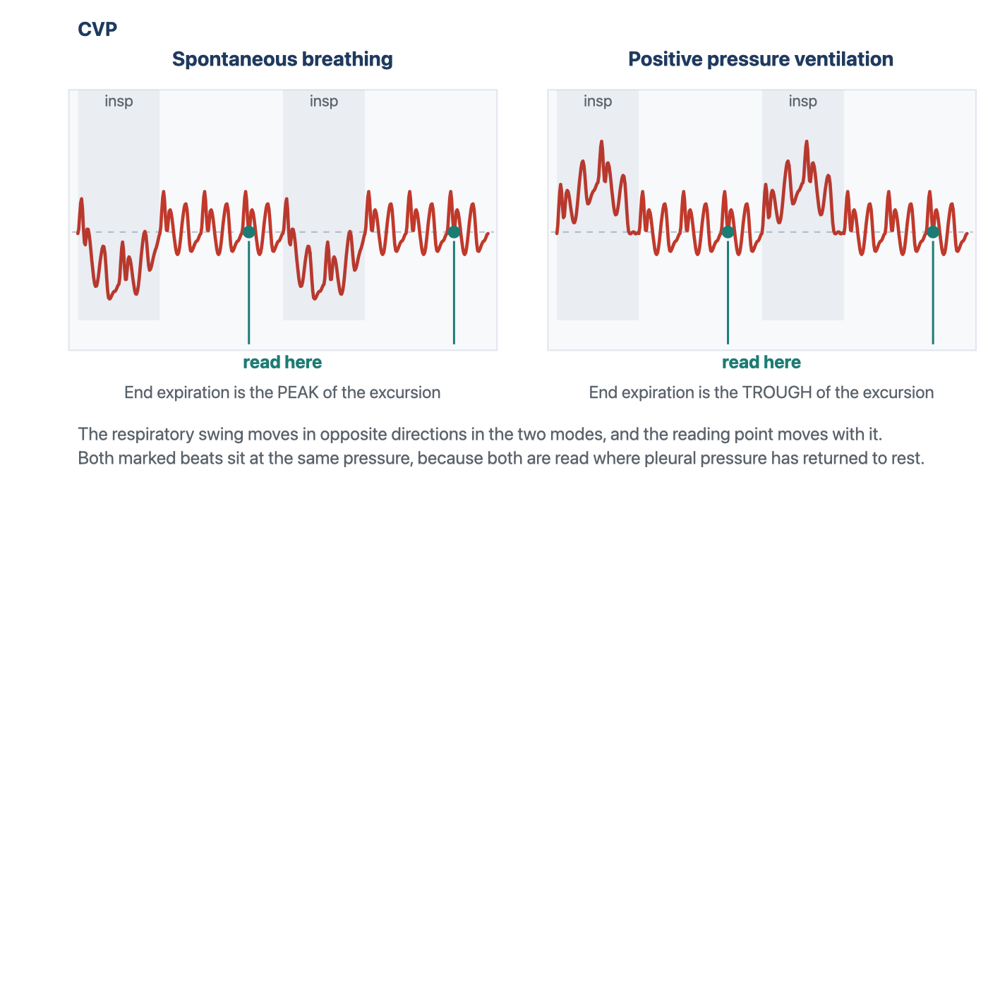
The respiratory swing reverses between the two modes and the reading point moves with it, but both readings are taken at the same physiological instant and both land at the same pressure. Reading a spontaneously breathing patient at the trough, or a ventilated patient at the peak, produces an error the size of the whole respiratory swing.
[Layout note: figure shown small here. On the web it is currently capped at 640px wide. Say if you want it smaller/larger, moved, cropped, or replaced.]

The exception: active expiration
The end-expiratory convention assumes that expiration is passive. If the patient actively recruits expiratory muscles, that assumption fails. Abdominal and expiratory muscle contraction progressively raises pleural pressure during expiration, pushing the right atrial pressure upward for a reason external to the heart. End expiration then becomes the point at which the respiratory pressure artifact may be greatest rather than smallest.
In active expiration, measure at the beginning of expiration, before expiratory muscle contraction has substantially raised pleural pressure.
This exception is not rare. Magder and colleagues reviewed tracings from 119 intensive care patients and found evidence of active expiration in 29%, divided between patterns in which venous pressure rose or fell during expiration. It could not be reliably predicted from clinical characteristics and had to be recognized from the waveform itself. When active expiration is present, the end-expiratory point can represent the moment of greatest respiratory-muscle contribution to pleural pressure, precisely the opposite of what the usual convention assumes.

Measuring a central venous pressure properly

The cardiac and respiratory landmarks tell us when to read the pressure. They do not guarantee that the pressure displayed at that moment is accurate. This matters particularly on the venous side, where the physiologic gradients of interest are only a few millimetres of mercury wide. An error that would barely change the interpretation of a systemic arterial pressure can equal or exceed the entire pressure gradient driving venous return.

The waveform therefore has to be trustworthy before a cursor is placed on it.

Start by looking at the trace rather than the digital number. Set the pressure scale so that the venous waveform occupies a useful portion of the display instead of sitting nearly flat at the bottom of a 0–50 mmHg channel. Sweep speed should match the question being asked: use a slower sweep when identifying the respiratory excursion and a faster one when separating the a, c and v waves and the x and y descents. Freeze or print the tracing before measuring it. The monitor may calculate a number continuously, but the clinician should be able to identify the physiologic event from which that number is being taken.

The dynamic response of the catheter–transducer system matters just as much. An overdamped venous trace can flatten the small c wave, blunt the x and y descents, and make a pathologic waveform appear deceptively normal. An underdamped system can introduce oscillations that were never present in the patient. A fast-flush test should therefore precede interpretation whenever waveform fidelity is uncertain. If the system cannot reproduce the pressure waveform faithfully, greater precision in cursor placement only produces a more precise measurement of the tubing.

Three additional conditions should then be checked:

Level and zero the transducer correctly. The transducer should be referenced to the phlebostatic axis and re-levelled whenever bed height or patient position changes. Hydrostatic error is numerically identical whether the pressure being measured is arterial or venous, but its relative importance is far greater when the true pressure is only a few mmHg. A small leveling error can therefore transform a normal right atrial pressure into an apparently elevated one.

Nothing should be infusing through the transduced lumen. Flow through the catheter creates an additional pressure gradient along the lumen, so the transducer records not only the pressure in the vessel but also part of the pressure required to drive the infusion. The displayed pressure can consequently be falsely elevated, particularly with smaller lumens or faster infusion rates.

Know where the catheter tip is. A central venous pressure can only be interpreted as right atrial pressure if the catheter is actually sampling the central thoracic venous compartment. A properly positioned tip in the lower superior vena cava or near the cavoatrial junction sees essentially the same pressure as the right atrium because there is normally little pressure gradient between them. A catheter that has migrated or was inadvertently positioned in another vessel, such as the contralateral subclavian or internal jugular vein, is measuring pressure at that location instead. Before interpreting an unexpected waveform or pressure as physiology, confirm that the catheter tip is where you think it is.
These technical checks are not separate from the physiology. They determine whether the waveform on the screen is actually the waveform generated by the patient. Only after they are satisfied does the cardiac and respiratory timing developed above become useful.

[Offshoot / At-the-Bedside link: Build the measurement as a fixed sequence. Confirm that the transducer is levelled at the phlebostatic axis and zeroed appropriately. Check the dynamic response of the catheter–transducer system with a fast flush if waveform fidelity is uncertain, and make sure nothing is infusing through the transduced lumen. Put the ECG and venous waveform on the same sweep. Determine whether expiration is passive from the respiratory movement of the baseline rather than assuming it from ventilator mode. If expiration is passive, use end expiration; if the patient is actively expiring, use the beginning of expiration before expiratory muscle pressure develops. Then place the cursor at the base of the c wave, the z point, of a beat occurring at that respiratory reference point. The purpose of the sequence is not ritual: each step removes a different way in which the measured pressure can cease to represent the physiologic pressure you intended to measure.]

Abnormal waveforms, and what each one is telling you
The abnormalities below are the classical series and they are presented in the order the mechanism suggests rather than by frequency. Each one is a disturbance of one of the four determinants named at the start: the rhythm, the tricuspid valve, right ventricular diastolic properties, or something outside the heart constraining it. The tracings are the case series from Magder's review of central venous pressure monitoring, which is where this curriculum's teaching on the subject originates.
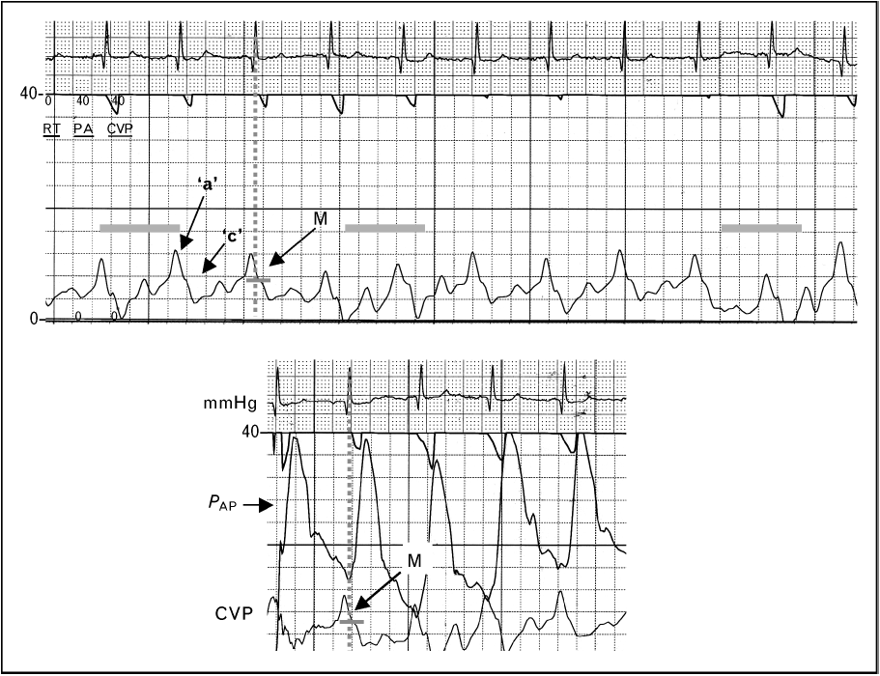
Large a waves in a patient with acute right ventricular pressure overload. The vertical line dropped from the QRS finds the trough between the a and the c wave, which is where the pressure is read. Reading the peak of the a wave, or accepting the monitor's mean, would report a substantially higher filling pressure than the ventricle actually has.Source: HemoSim hemodynamics module (v2022), slide 299, after Magder, Central venous pressure monitoring, Curr Opin Crit Care 2006.
[Layout note: figure shown small here. On the web it is currently capped at 640px wide. Say if you want it smaller/larger, moved, cropped, or replaced.]
Apply the compliance equation. A tall a wave means the atrium moved more volume, or the chamber it moved the volume into was stiffer, or the orifice it moved the volume through was narrowed, and the differential follows directly from those three.
The commonest version is a stiff right ventricle. Anything that chronically pressure-loads the right ventricle hypertrophies it, and a hypertrophied ventricle is a less compliant one, so the same atrial contraction generates a larger pressure rise. Pulmonary hypertension of any cause is the usual setting. The acute version is the same physiology on a shorter timescale: a submassive pulmonary embolus abruptly raises right ventricular afterload, the ventricle dilates onto a steep part of its diastolic pressure-volume relationship, and the a wave grows. The third mechanism is obstruction rather than stiffness. In tricuspid stenosis the atrium contracts against a narrowed orifice and generates a high pressure to drive flow across it, so the a wave is tall for a reason that has nothing to do with the ventricle. In all three the mean rises with the a wave, the monitor reports a high filling pressure, and the reflex is to withhold volume from a patient who may well be underfilled. Read the z point.
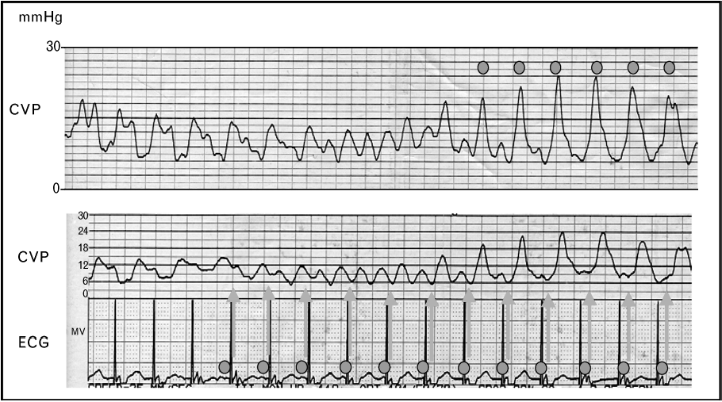
Cannon a waves. When atrial systole falls during ventricular systole the atrium contracts against a closed tricuspid valve and the entire pressure it generates is delivered backwards into the venous system. The lower panel pairs the venous trace with the paced electrocardiogram, which is what identifies the mechanism.Source: HemoSim hemodynamics module (v2022), slide 301, after Magder, Central venous pressure monitoring, Curr Opin Crit Care 2006.
[Layout note: figure shown small here. On the web it is currently capped at 640px wide. Say if you want it smaller/larger, moved, cropped, or replaced.]
A cannon a wave is what happens when the atrium contracts against a tricuspid valve that is already shut. Ordinarily atrial systole precedes ventricular systole and the volume it ejects has somewhere to go. If the two coincide, the volume has nowhere to go, the compliance term in the equation collapses towards that of a closed chamber, and the pressure the atrium generates is delivered in its entirety into the venous system as a single very tall spike.
The settings are all forms of atrioventricular dissociation or retrograde conduction: complete heart block, ventricular tachycardia, ventricular pacing with retrograde ventriculo-atrial conduction, and atrioventricular nodal reentrant tachycardia, where atrial and ventricular activation are near simultaneous. The distinction that carries diagnostic weight is between intermittent and irregular cannon waves and regular ones on every beat. In true dissociation the atria and ventricles run at independent rates, so the timing of atrial systole relative to the closed valve drifts, and cannon waves appear irregularly whenever the two happen to coincide. In one to one retrograde conduction every ventricular beat is followed by an atrial beat at a fixed short interval, so every beat produces a cannon wave.
That distinction has an immediate use. A patient in a wide complex tachycardia with intermittent cannon a waves on the venous trace has demonstrable atrioventricular dissociation, and atrioventricular dissociation in a wide complex tachycardia is strong evidence for ventricular tachycardia. The venous trace is doing electrophysiology.
The regular version is the hemodynamic substrate of pacemaker syndrome. Ellenbogen and colleagues studied 16 patients with a left ventricular ejection fraction above 35 percent during atrial, ventricular and ventriculo-atrial pacing at a cycle length of 600 milliseconds. During ventriculo-atrial pacing cardiac output fell by 10 percent, forearm vascular resistance rose from 52 plus or minus 7 to 70 plus or minus 9 units, and plasma norepinephrine rose from 183 plus or minus 27 to 232 plus or minus 27 pg/mL. Regional alpha blockade with intra-arterial phentolamine nearly abolished the vascular response, placing the mechanism in the arterial baroreflex rather than in the venous congestion itself. The cannon wave is the visible marker of a loss of atrioventricular synchrony whose cost is measurable in output and in reflex vasoconstriction, and which is correctable by restoring synchrony.
The mirror image of a cannon wave is no wave at all. In atrial fibrillation there is no organised atrial systole, so there is no a wave, and the atrial relaxation component of the x descent goes with it. What remains is a c-v pattern, often with an irregular baseline, and with beat to beat variation in the height of the v wave because the diastolic filling interval preceding each beat differs.
Two consequences follow. The first is practical: with the a wave gone, the landmark most clinicians use to find end diastole is gone, and the z point, identifiable from the QRS alone, becomes the only defensible reading point. The second is physiological and it deserves more weight than it usually gets. The contribution of atrial systole to ventricular filling is negligible when the ventricle is compliant, because a compliant ventricle fills perfectly well passively. It becomes substantial when the ventricle is stiff, because a stiff ventricle depends on the atrial kick to complete its filling. Those are precisely the patients whose a wave was tall in the first place. So the patients who lose the most hemodynamically from new atrial fibrillation are identifiable in advance from the venous trace, and they are the ones in whom rate control alone is least likely to be sufficient.
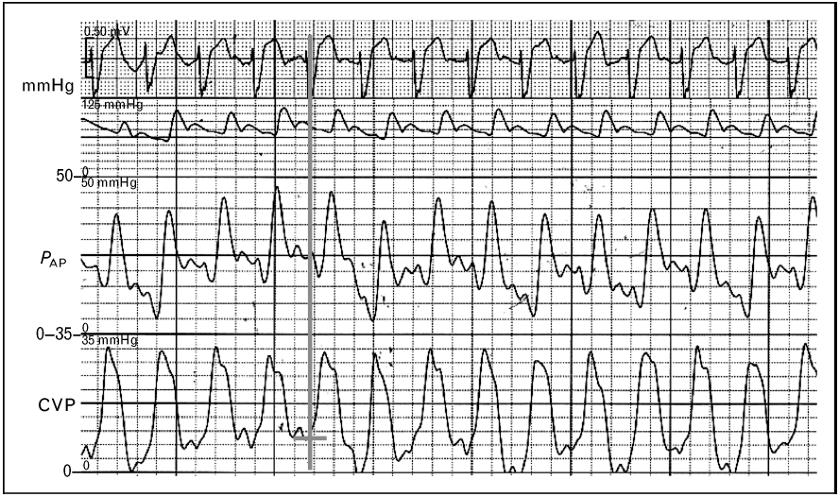
Tricuspid regurgitation. The x descent has gone, the c and v waves have merged into one broad systolic wave, and the venous trace has taken on the appearance of a ventricular trace. The electrocardiogram at the top is what establishes that the large wave occupies ventricular systole.Source: HemoSim hemodynamics module (v2022), slide 303, after Magder, Central venous pressure monitoring, Curr Opin Crit Care 2006.
[Layout note: figure shown small here. On the web it is currently capped at 640px wide. Say if you want it smaller/larger, moved, cropped, or replaced.]
An incompetent tricuspid valve does two things to the trace at once, and only one of them is the tall v wave everyone remembers. During ventricular systole the regurgitant jet delivers volume into the atrium at ventricular pressures. The v wave therefore grows and, more importantly, arrives early, since it no longer has to wait for venous return to fill the atrium. At the same time the x descent, which exists only because the atrium is sealed off from the ventricle during ejection, is abolished. The c wave and the early v wave merge across the gap the x descent used to occupy, and the result is a single broad systolic wave, the fused CV wave. In severe regurgitation the venous trace comes to resemble a ventricular pressure trace, which is the origin of the term ventricularisation.
The identification is made against the electrocardiogram, because the whole point is that a large deflection now occupies ventricular systole where a descent should be. This is where a habit of timing rather than pattern matching earns its keep.
A recent analysis supports the emphasis on the descent rather than the peak. Akabane and colleagues analysed the central venous pressure tracings of 436 surgical patients who had preoperative echocardiography, constructing indices from the waveform and testing them against echocardiographic regurgitation grade. The difference between the c wave and the y descent, and the difference between the x descent and the y descent, both varied significantly across severity, and the x descent minus y descent index separated none-to-moderate from severe regurgitation with an area under the receiver operating characteristic curve of 0.83, with a wide confidence interval of 0.68 to 0.98 reflecting the small number of severe cases. Their deep learning classifier reached a validation accuracy of 0.97, which is a statement about the information the waveform contains rather than a bedside test. The usable lesson is the first one: what changes reliably with severity is the relationship between the descents, so look for the missing x and not only for the tall v.
Three practical consequences follow. The mean right atrial pressure rises in significant regurgitation, so the trace reports a high filling pressure in a patient whose effective forward filling may be inadequate. During catheter placement a ventricularised atrial trace can be mistaken for a right ventricular trace and prompt inappropriate advancement. And thermodilution cardiac output becomes unreliable when a fraction of the indicator is shuttled backwards and forwards across the valve, which Module I16 takes up with the direction of the error.
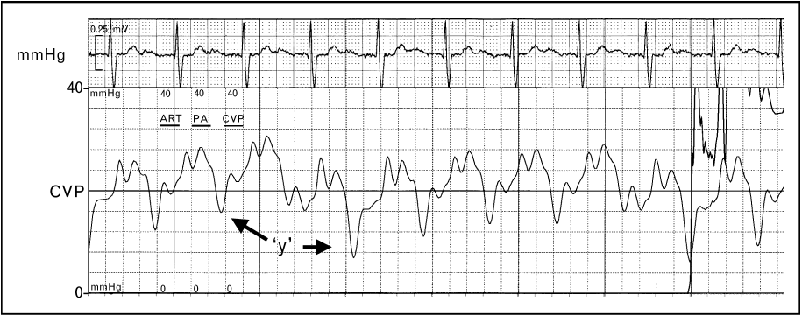
A deep and abrupt y descent. Early diastolic emptying is unimpeded, so the pressure falls steeply the moment the tricuspid valve opens, and then rebounds just as steeply because the ventricle reaches the limit of what it will accept.Source: HemoSim hemodynamics module (v2022), slide 305, after Magder, Central venous pressure monitoring, Curr Opin Crit Care 2006.
[Layout note: figure shown small here. On the web it is currently capped at 640px wide. Say if you want it smaller/larger, moved, cropped, or replaced.]
A prominent y descent is a statement about early diastole, and specifically about the combination of a high atrial pressure at the moment the valve opens and a ventricle that offers little resistance to the first part of filling. The pressure falls steeply because the gradient across the open valve is large. It then rebounds abruptly because the chamber receiving the volume is stiff or externally constrained and reaches its limit almost immediately. The steep descent and the abrupt plateau are two halves of the same finding and neither is interpretable without the other.
The conditions that produce it combine a high venous pressure with a non-compliant right ventricle: right ventricular hypertrophy from chronic pulmonary hypertension, constrictive pericarditis, and restrictive cardiomyopathy. Severe tricuspid regurgitation belongs on the list for a different reason, because the atrium has an unusually large volume to discharge when the valve opens.
The tracing above comes from a patient with chronic pulmonary hypertension and carries two further features that are easy to miss and useful when present. The interval between the a wave and the c wave is prolonged, reflecting the prolonged right ventricular contraction that pressure overload produces, and the c wave itself is elevated, because a markedly raised right ventricular systolic pressure is transmitted back onto the closed tricuspid valve. Neither is typical of constriction or restriction, so an a to c delay with a tall c wave alongside a prominent y descent argues for pulmonary hypertension over a pericardial cause.
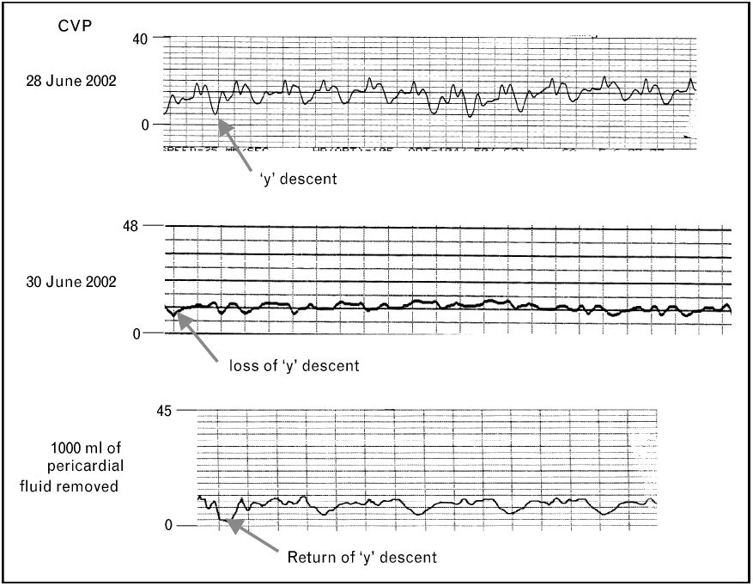
The same patient across the development and drainage of a tamponade. The y descent is present, then lost as the pericardium fills, then returns after 1000 mL is removed. This is the cleanest demonstration in the curriculum that the waveform reports a mechanical constraint rather than a property of the patient.Source: HemoSim hemodynamics module (v2022), slide 308, after Magder, Central venous pressure monitoring, Curr Opin Crit Care 2006.
[Layout note: figure shown small here. On the web it is currently capped at 640px wide. Say if you want it smaller/larger, moved, cropped, or replaced.]
Tamponade is the cleanest application of the compliance equation in the whole module. Once the pericardium is full, the volume inside it is effectively fixed, and pericardial pressure acts on all four chambers at once. Blood can only enter the right heart at a moment when something else inside the pericardium is getting smaller. That moment is ventricular ejection. So during systole, ventricular ejection creates room within the fixed pericardial volume while atrial relaxation and downward displacement of the tricuspid annulus increase atrial capacity. Right atrial pressure can therefore fall despite continued venous inflow, preserving and often accentuating the x descent. In early diastole, when the atrium would normally empty into a ventricle that is enlarging, the ventricle cannot enlarge, because doing so would require the total pericardial volume to increase. The y descent is attenuated or abolished, and the trace acquires its characteristic single-descent appearance.
Reddy and colleagues established the hemodynamic frame in 19 patients studied before and after pericardiocentesis. In the 14 with tamponade, right atrial pressure fell from 16 plus or minus 4 to 7 plus or minus 5 mmHg with drainage, cardiac output rose from 3.87 plus or minus 1.77 to 7 plus or minus 2.2 L/min, and inspiratory systemic arterial pulse pressure rose from 45 plus or minus 29 to 81 plus or minus 23 mmHg. In every tamponade patient the right ventricular end-diastolic pressure was elevated and equal to the pericardial pressure, and that equalisation was uniformly absent in the five patients with an effusion but without tamponade. Equalisation of diastolic pressures is therefore the hemodynamic definition of the condition, and the flattened venous trace is what equalisation looks like on a single channel.
One point of caution about the source material, because the curriculum's own slides are inconsistent on it. The slide text describes tamponade as causing loss of both the x and the y descent. The mechanism above does not support that, the standard descriptions of tamponade physiology, such as Appleton and colleagues' review, do not support it, and the annotated tracing on the same slide marks the loss of the y descent alone. Read tamponade as a preserved x with an absent y. A trace that has lost both descents is a flat trace, and a flat trace on a venous channel should prompt a fast flush test before it prompts a diagnosis.
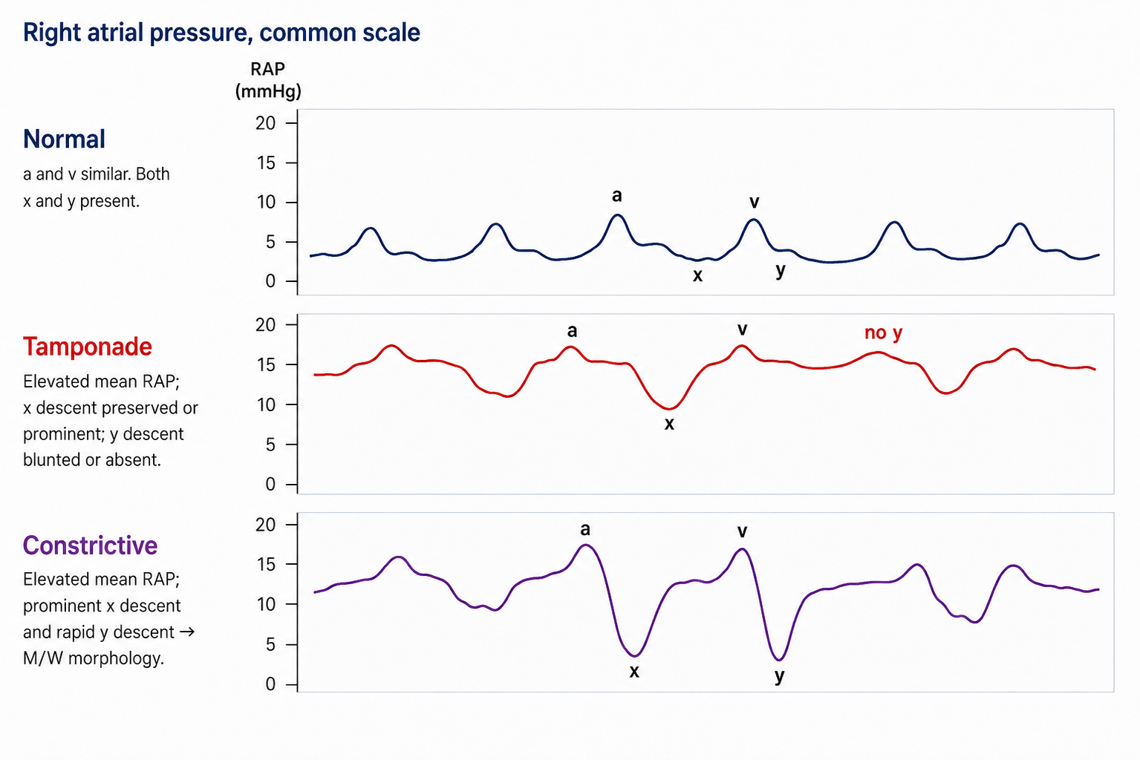
The two conditions equalise diastolic pressures and raise the mean right atrial pressure to a similar degree, so the mean value cannot separate them. The y descent can. Constriction permits rapid early filling and then stops it abruptly, giving two deep descents per cycle. Tamponade prevents early filling altogether and leaves one.
[Layout note: figure shown small here. On the web it is currently capped at 640px wide. Say if you want it smaller/larger, moved, cropped, or replaced.]
Both conditions raise the mean right atrial pressure, both equalise the diastolic pressures of all four chambers, and both present with predominantly right-sided heart failure. The mean number is therefore useless for separating them, and the waveform is not. The discriminator is the y descent, and the reason is a difference in when in the cycle the constraint operates.
In constriction the pericardium is rigid but the volume inside it is not yet at its limit when diastole begins, so early filling is not merely permitted but accelerated, the atrial pressure being high and the ventricle at that instant small. Filling proceeds rapidly until the ventricle reaches the fixed shell and then stops abruptly. On the ventricular trace this is the dip and plateau, or square root sign. On the venous trace it is a steep y descent followed by an immediate plateau, and combined with the preserved x descent it gives the classical M or W shaped tracing with two deep descents per cycle. In tamponade the constraint operates from the very start of diastole, because the pericardial space is already at its limit, so there is no unimpeded early phase and no y descent. Kussmaul's sign separates them in the same direction: a rise, or a failure to fall, in venous pressure during spontaneous inspiration means the extra venous return recruited by the inspiratory fall in pleural pressure has nowhere to go, which is the situation in constriction, where the rigid shell isolates the chambers from that fall. The inspiratory fall in right atrial pressure is preserved in tamponade, which is why Kussmaul's sign is not a feature of it.
The limit of the waveform has to be stated, because this is exactly where a confident pattern-reader goes wrong. A high mean pressure with equalised diastolic pressures and a prominent y descent narrows the field to constriction and restrictive myocardial disease, and it does not separate them, because both share that picture. Two catheterisation studies show how much further one has to go. Hurrell and colleagues studied 36 patients with high-fidelity manometry and respirometry, 15 with surgically proven constriction, and found that the conventional criteria based on equalisation of pressures lacked sensitivity and specificity and failed to distinguish the groups, while discordance between right and left ventricular systolic pressures during inspiration, the signature of enhanced ventricular interdependence, did distinguish them. Talreja and colleagues formalised that in 100 consecutive patients, 59 with surgically documented constriction and 41 with restrictive myocardial disease, reporting that the predictive accuracy of any conventional catheterisation criterion was below 75 percent while the systolic area index, the ratio of right to left ventricular systolic pressure-time area in inspiration versus expiration, had a sensitivity of 97 percent and a predictive accuracy of 100 percent. Geske and colleagues give the contemporary synthesis.
So the right atrial waveform is a screening instrument of real value: it tells you that filling is constrained, it tells you whether the constraint operates in early diastole or throughout it, and it therefore separates tamponade from the constriction and restriction pair. It does not separate constriction from restriction, and no single-chamber recording can, because the finding that distinguishes them is a relationship between two ventricles across the respiratory cycle.
Finding | Mechanism | What to think of | Mean RAP
Prominent a wave | Atrium contracting into a stiff ventricle or through a narrowed valve | Pulmonary hypertension, RV hypertrophy, acute RV pressure overload, tricuspid stenosis | Raised, and the mean overstates the true filling pressure
Cannon a wave | Atrium contracting against a closed tricuspid valve | AV dissociation, complete heart block, VT, ventricular pacing with retrograde conduction, AVNRT | Intermittently spiked
Absent a wave | No organised atrial systole | Atrial fibrillation, and any rhythm without effective atrial contraction | Unchanged, but the reading point must be the z point
Fused CV wave, absent x descent | Systolic regurgitant flow into the atrium, and loss of atrial isolation during ejection | Tricuspid regurgitation | Raised, and forward filling may still be inadequate
Prominent y descent | High atrial pressure emptying into a ventricle that is stiff but not obstructed early | RV hypertrophy in pulmonary hypertension, constriction, restriction, RV failure, severe TR | Raised
Absent y descent, preserved x | Filling possible only while the ventricles are emptying | Cardiac tamponade | Raised, with equalised diastolic pressures
Deep x and deep y, the M or W pattern | Rapid early filling that stops abruptly at a fixed pericardial limit | Constrictive pericarditis, restrictive cardiomyopathy | Raised, with equalised diastolic pressures
[Offshoot / At-the-Bedside link: When a venous trace looks abnormal, four questions in order will place almost anything you meet. Is there an a wave, and does it come at a sensible interval before every QRS? That answers the rhythm. Is there an x descent? Its absence, with a broad wave filling ventricular systole, is tricuspid regurgitation until proven otherwise. Is there a y descent, and if so how steep? Absent means tamponade physiology, steep with an abrupt plateau means a stiff or constrained ventricle. And is the whole trace moving with the breath in the direction the ventilatory mode predicts? If it is not, the patient is expiring actively or the abdomen is doing something, and the number you were about to record is not a filling pressure. None of these questions requires you to remember a named pattern.]

What the waveform is worth
The argument running through the last three modules is that right atrial pressure is a poor answer to the question most often asked of it, and nothing here rehabilitates the mean value as a volume status number. What the waveform does is change the question. It is not a filling pressure with decoration, it is a mechanical recording of four separate things the right heart is doing, each diagnosable in its own right without converting a pressure into a volume and therefore without the compliance assumption that made the mean uninterpretable. A cannon a wave is not weak evidence about volume, it is direct evidence of atrioventricular dissociation. A broad systolic CV wave with loss of the x descent is not weak evidence about volume; it is a mechanical signature of systolic regurgitant communication across the tricuspid valve. An absent y descent is a statement about when in the cycle the heart is permitted to fill. That is why the long argument over whether central venous pressure should be measured at all, set out by De Backer and Vincent as ten questions and ten answers, is really an argument about one use of one number rather than about the catheter. Two habits carry almost all of the remaining value and both are free: look at the trace instead of the number, and place the cursor at the z point/base of the c wave at the appropriate respiratory reference point, normally end expiration, or the beginning of expiration when expiration is active.
The same discipline transfers directly to the other waveform a pulmonary artery catheter provides. Module I15 takes the catheter past the tricuspid valve and applies the same logic to the wedge tracing, where the a and v waves have different meanings, where the large v wave of mitral regurgitation does to the wedge what the fused CV wave does here, and where a chain of assumptions has to hold before the pressure can be read as a left ventricular end-diastolic pressure at all. Module I9 takes up the right ventricle itself, the chamber whose diastolic properties this trace has been reporting on throughout. And the reading of the venous waveform as a marker of organ congestion, rather than of cardiac filling, belongs to the Expert pathway.

References
To DROP a reference, strike it. To ADD one, write [add: author, year, journal, roughly what it is] rather than typing the citation out. Do not correct the text of an entry here: every author list, volume, issue, page range, year and DOI is fetched from PubMed when the page is rebuilt, so an edit made here is discarded and a typo made here is caught. This list is what the page currently carries.
1. Magder S. Central venous pressure monitoring. Curr Opin Crit Care. 2006;12(3):219-227. doi:10.1097/01.ccx.0000224866.01453.43.
2. Magder S. Right atrial pressure in the critically ill: how to measure, what is the value, what are the limitations? Chest. 2017;151(4):908-916. doi:10.1016/j.chest.2016.10.026.
3. Magder S. Understanding central venous pressure: not a preload index? Curr Opin Crit Care. 2015;21(5):369-375. doi:10.1097/MCC.0000000000000238.
4. Magder S, Serri K, Verscheure S, Chauvin R, Goldberg P. Active expiration and the measurement of central venous pressure. J Intensive Care Med. 2018;33(7):430-435. doi:10.1177/0885066616678578.
5. Magder S. Invasive intravascular hemodynamic monitoring: technical issues. Crit Care Clin. 2007;23(3):401-414. doi:10.1016/j.ccc.2007.07.004.
6. De Backer D, Vincent JL. Should we measure the central venous pressure to guide fluid management? Ten answers to 10 questions. Crit Care. 2018;22(1):43. doi:10.1186/s13054-018-1959-3. Free full text.
7. Ellenbogen KA, Thames MD, Mohanty PK. New insights into pacemaker syndrome gained from hemodynamic, humoral and vascular responses during ventriculo-atrial pacing. Am J Cardiol. 1990;65(1):53-59. doi:10.1016/0002-9149(90)90025-v.
8. Akabane S, Asamoto M, Azuma S, Otsuji M, Uchida K. Assessment of the relationship between central venous pressure waveform and the severity of tricuspid valve regurgitation using data science. Sci Rep. 2024;14(1):24839. doi:10.1038/s41598-024-74890-8. Free full text.
9. Reddy PS, Curtiss EI, O'Toole JD, Shaver JA. Cardiac tamponade: hemodynamic observations in man. Circulation. 1978;58(2):265-272. doi:10.1161/01.cir.58.2.265.
10. Hurrell DG, Nishimura RA, Higano ST, Appleton CP, Danielson GK, Holmes DR Jr, Tajik AJ. Value of dynamic respiratory changes in left and right ventricular pressures for the diagnosis of constrictive pericarditis. Circulation. 1996;93(11):2007-2013. doi:10.1161/01.cir.93.11.2007.
11. Talreja DR, Nishimura RA, Oh JK, Holmes DR. Constrictive pericarditis in the modern era: novel criteria for diagnosis in the cardiac catheterization laboratory. J Am Coll Cardiol. 2008;51(3):315-319. doi:10.1016/j.jacc.2007.09.039.
12. Geske JB, Anavekar NS, Nishimura RA, Oh JK, Gersh BJ. Differentiation of constriction and restriction: complex cardiovascular hemodynamics. J Am Coll Cardiol. 2016;68(21):2329-2347. doi:10.1016/j.jacc.2016.08.050.
13. Appleton C, Gillam L, Koulogiannis K. Cardiac tamponade. Cardiol Clin. 2017;35(4):525-537. doi:10.1016/j.ccl.2017.07.006.

